|  |
| --- |
| seecs-nust |
| Assignment # 3 |
| Formal Methods-BESE(5B) |
|  |
| Submitted by: Maimoona Khalid (33422|111677) |
| 5/28/2017 |

|  |
| --- |
| Assignment 3- Formal Methods |

Part a: Prepare and enhance the light controller model.

Explanation:

The levels of light keep on changing with each pressing of button.

Code:

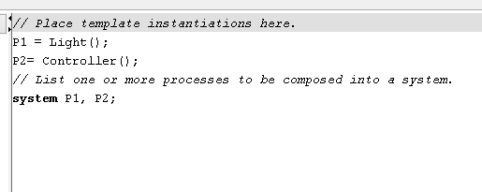

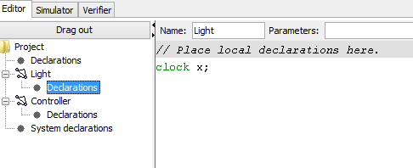

Images of Model:

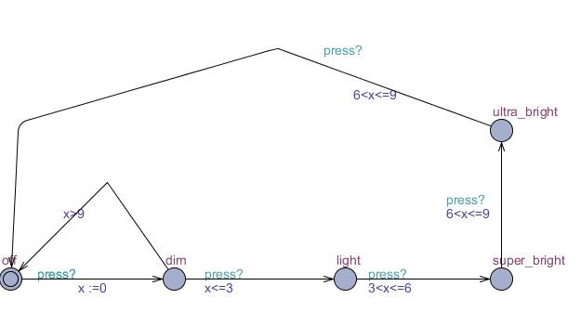

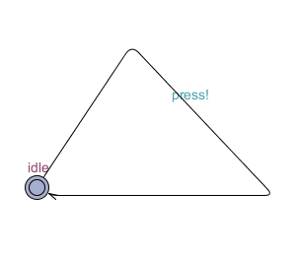

Part b: Construct a model of your own.

Explanation:

In this example, we simulate the automatic door opening system. As soon as a movement is detected the door opens up. As soon the person enters through the door, it prepares to get closed.

Code:

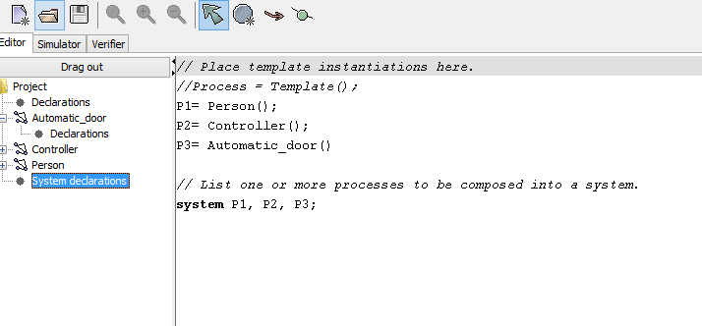

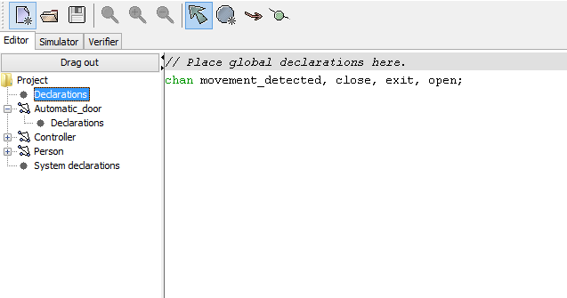

Images of Model:

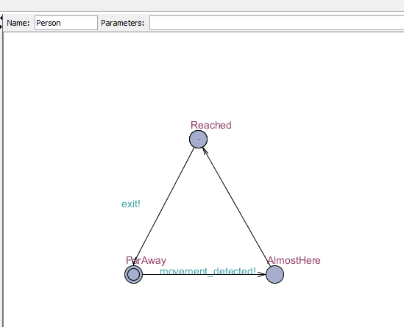

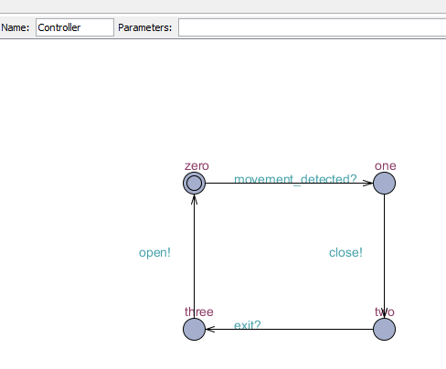

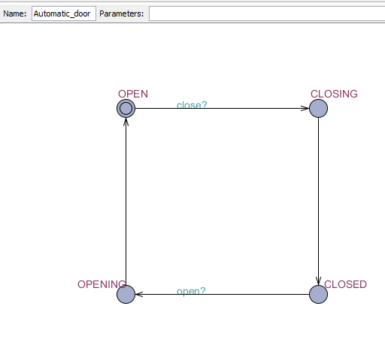

Explanation:

https://github.com/maimoona96/FM_Assignment